# Capgemini Big Data and Azure Engineering Batch

## Database Fundamentals and SQL programming

## Day 4:

Assignments

There is a Product Table like as the following columns and the SalesOrderDetail table.

1. Product Table

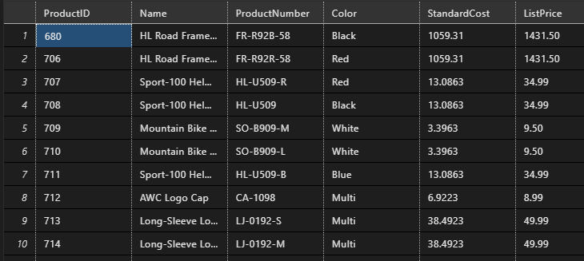

1. SalesOrderDetail table

Assignments:

1. Write tSQL query to perform INNER join between Product and SalesOrderDetail table
2. Write tSQL query to perform FULL OUTER join between the Product and SalesOrderDetails table.
3. Write tSQL query to perform LEFT OUTER JOIN to join the Product and SalesOrderDetail table.
4. Write tSQL query to execute Right OUTER JOIN to join the Product and SalesOrderDetail table.
5. Write a tSQL query to fetch the current datetime from the system.